LIBRARY MANAGEMENT SYSTEM
Technical Story Card

Revision History
Version No. | Date | Prepared by / Modified by | Significant Changes

Glossary
Abbreviation | Description
BSC | Business Story Card
TSC | Technical Story Card
DOJ | Date of joining

Table of Contents
1 Introduction 3
2 Scope of Change 3
3 List of impacted modules 3
4 Design and Detailed technical updates 4
4.1 Process model 4
4.1.1 Use case Model 4
4.1.2 Sequence diagram 4
4.2 Proposed user Interface design 4
4.3 Database design changes 4
4.4 Refactoring related changes 4
4.5 Construction strategy and re-use 4
5 Details of Alternative Design Approach 4
6 Other Technical changes 5
6.1 Automation tasks / changes 5
6.2 CI / Build relates tasks / changes 5
6.3 Non-functional related changes 5
7 Additional details 5
7.1 Open Questions / clarifications / Assumptions 5
7.2 Additional notes to technical team 5
8 References 5

Introduction
The project titled Library Management System is Library Management software for monitoring and controlling the transactions in a library .The project mainly focuses on basic operations in a library like searching books and return date of books.

This project of “LIBRARY MANAGEMENT” helps us to search the particular book by author name ,book name and category, so that we can retrieve the details of books available in the library. We can also check the particular book is issued or stock available in the library. In this project we can know the return date of the issued book from the library.

Throughout the project the focus has been on presenting information and comments in an easy and intelligible manner. The project is very useful for those who want to know about Library Management System.

Scope of Change
Change will not be entertained and whatever specifications mentioned in this document is final.

List of impacted modules
All the functional modules will be created from scratch.

Design and Detailed technical updates

Process model

Use case Model
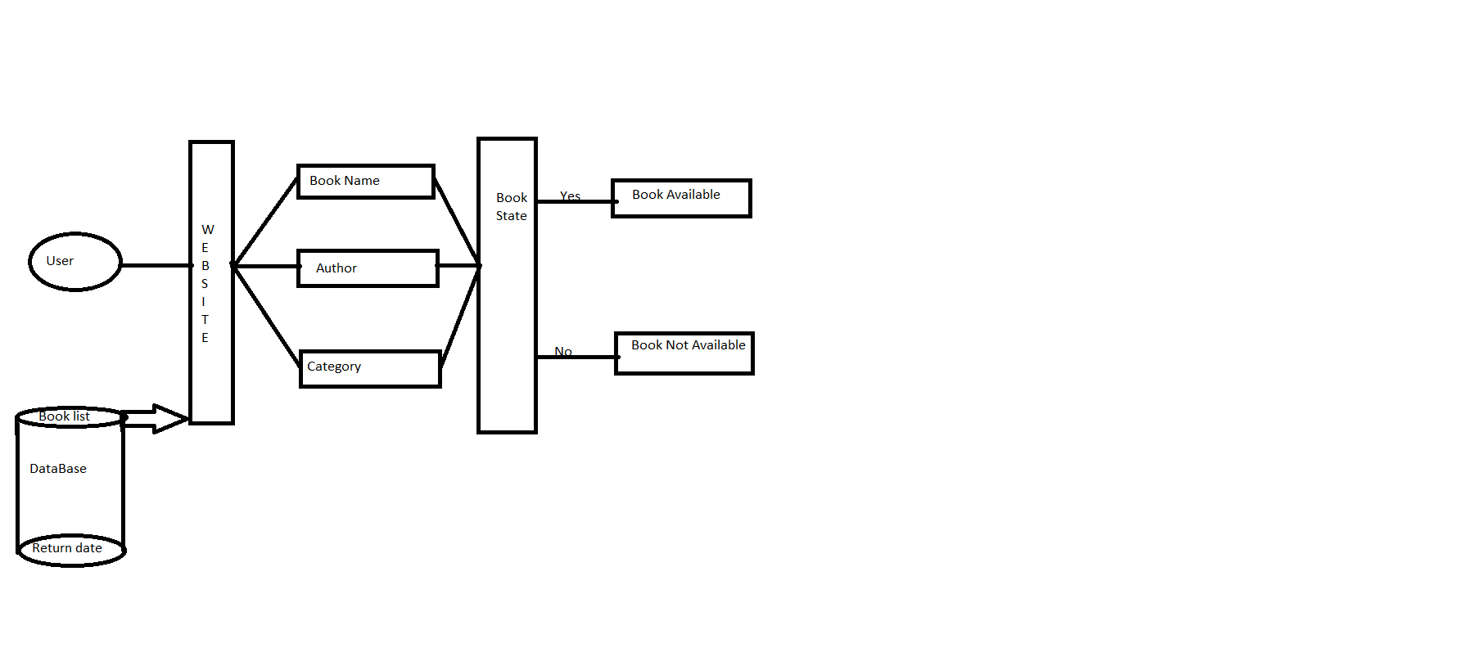

Brief Description | User search for book
Basic Flow | User can search for a book by three options  - Search by Bookname  - Search by Authorname  - Search by Category  Using any of these options user will search for the book.It will display the availability of books with book details like BookNo,BookName,Author and Category.
Alternate Flow | The system will validate the information provided. If the book is not available the input form will be redirected with error message like BookNotFoundException.
Validation | Bookname/Authorname/Category is required and minimum 3 characters and max 30 characters.
Pre-Conditions | User should have network access and Browser with latest updates.
Post-Conditions | Book status will be displayed.



Brief Description | Home page
Basic Flow | User can search for a book by three options  - Search by Bookname  - Search by Authorname  - Search by Category
Alternate Flow | The system will validate the information provided. If the book is not available the input form will be redirected with error message like BookNotFoundException.
Validation | Bookname/Authorname/Category is required and minimum 3 characters and max 30 characters.
Pre-Conditions | User should have network access and Browser with latest updates.
Post-Conditions | Book status will be displayed.

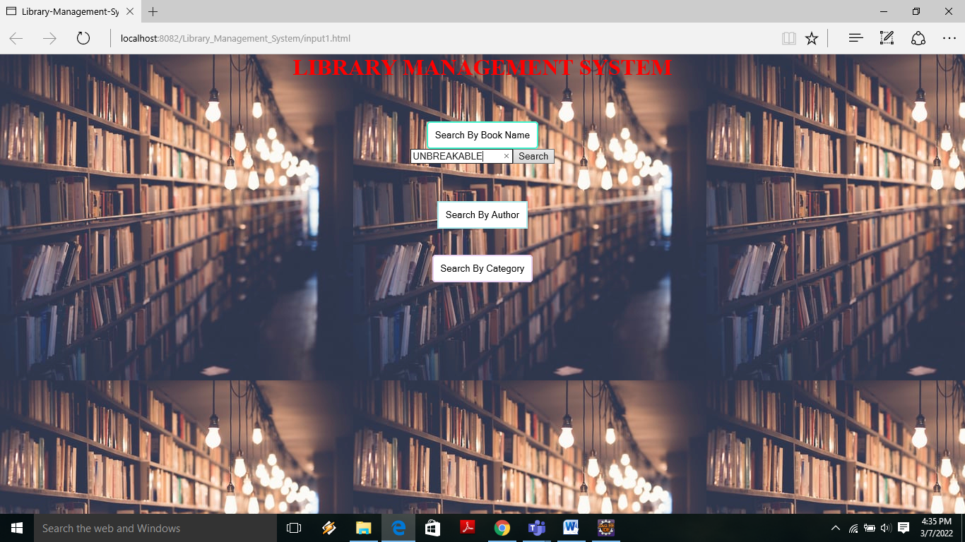

Brief Description | Search by bookname
Basic Flow | User will search for the book by entering the book name and then click on search button. It will display the availability of books with book details like BookNo,BookName,Author and Category.
Alternate Flow | The system will validate the information provided. If the book is not available the input form will be redirected with error message like BookNotFoundException.
Validation | Valid bookname is required and minimum 3 characters and max 30 characters.
Pre-Conditions | User should have network access and Browser with latest updates.
Post-Conditions | Book status will be displayed.

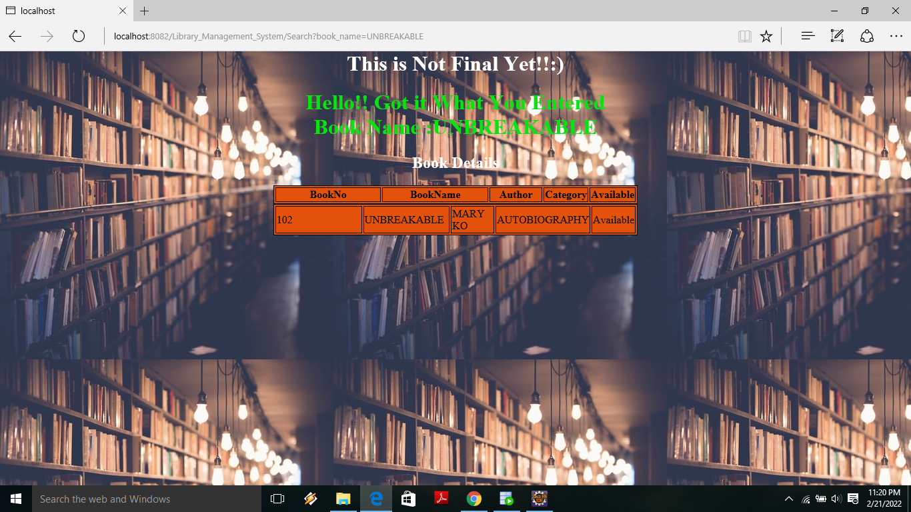

Brief Description | Output page of Search by bookname
Basic Flow | User will search for the book by entering the book name and if the book is available display book details like BookNo, BookName, Author and Category.
Alternate Flow | The system will validate the information provided. If the book is not available the input form will be redirected with error message like BookNotFoundException.
Validation | Valid bookname is required and minimum 3 characters and max 30 characters.
Pre-Conditions | User should have network access and Browser with latest updates.
Post-Conditions | Book status will be displayed.

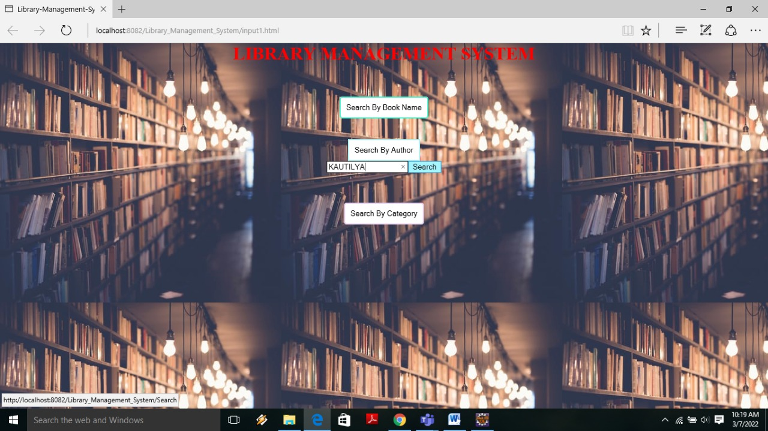

Brief Description | Search by Author
Basic Flow | User will search for the book by entering the Author name and then click on search button. It will display the availability of books with book details like BookNo,BookName,Author and Category.
Alternate Flow | The system will validate the information provided. If the book is not available the input form will be redirected with error message like BookNotFoundException.
Validation | Valid Authorname is required and minimum 3 characters and max 30 characters.
Pre-Conditions | User should have network access and Browser with latest updates.
Post-Conditions | Book status will be displayed.

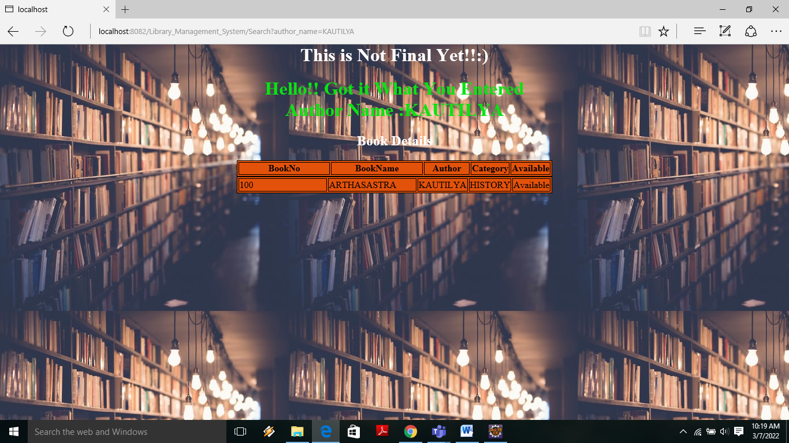

Brief Description | Output page of Search by Author
Basic Flow | User will search for the book by entering the Author name and if the book is available display book details like BookNo, BookName, Author and Category.
Alternate Flow | The system will validate the information provided. If the book is not available the input form will be redirected with error message like BookNotFoundException.
Validation | Valid Authorname is required and minimum 3 characters and max 30 characters.
Pre-Conditions | User should have network access and Browser with latest updates.
Post-Conditions | Book status will be displayed.

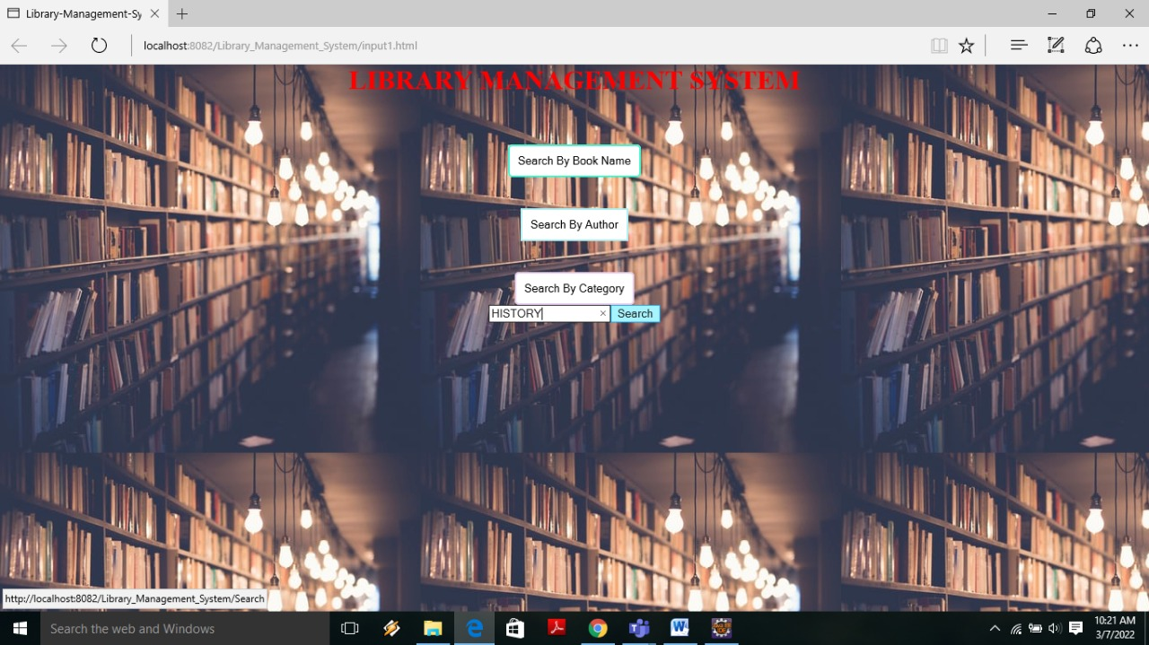

Brief Description | Search by Category
Basic Flow | User will search for the book by entering the category of book and then click on search button. It will display the availability of books with book details like BookNo,BookName,Author and Category.
Alternate Flow | The system will validate the information provided. If the book is not available the input form will be redirected with error message like BookNotFoundException.
Validation | Valid Category of book is required and minimum 3 characters and max 30 characters.
Pre-Conditions | User should have network access and Browser with latest updates.
Post-Conditions | Book status will be displayed.

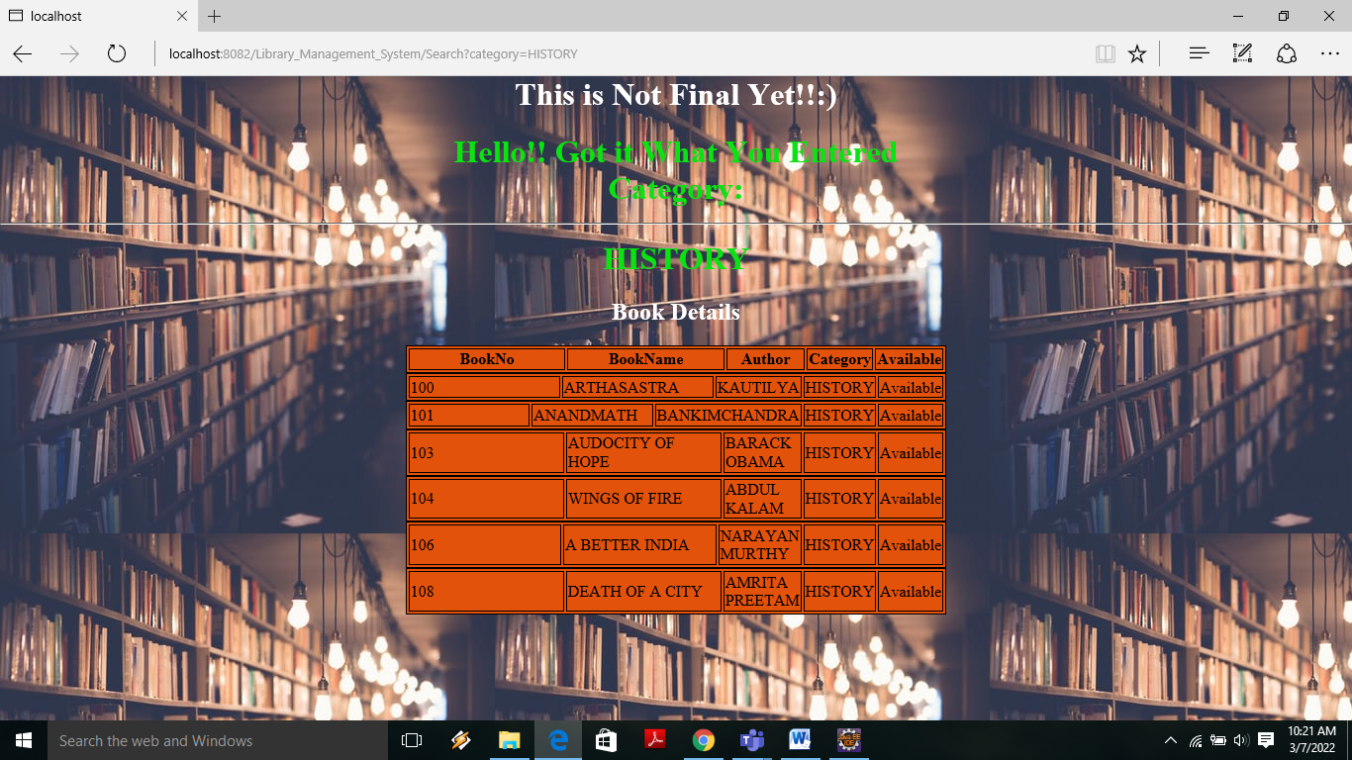

Brief Description | Output page of Search by Category
Basic Flow | User will search for the book by entering the category of book and if the book in that category is available display book details like BookNo, BookName, Author and Category.
Alternate Flow | The system will validate the information provided. If the book is not available the input form will be redirected with error message like BookNotFoundException.
Validation | Valid Category of book is required and minimum 3 characters and max 30 characters.
Pre-Conditions | User should have network access and Browser with latest updates.
Post-Conditions | Book status will be displayed.
Architecture Diagram

Layer
Logical View
Technology/ Framework

UI Components
Presentation Layer
HTML/ CSS/ JavaScript/ AJAX/ Angular
BookName
Search
Category

AuthorName

Web-Server Classes
Java 1.8/ Spring MVC
Application/ Business Layer
Configuration
Controllers

Service
REST Controllers

Entity/ Model Classes

Data Access Layer
Repository classes
Hibernate ORM

Oracle 11g Database

Presentation Layer:
This layer consists of all UI components.
- Bookname Component: User can use the Bookname component to search for a book by it’s bookname..
- Authorname component: User can use the Authorname component to search for a book by it’s authorname
- Category component: User can use the Category component to search for a book by it’s category
- Search component: By using search component user can search for a book by its Bookname/Authorname/Category
Application Layer:
This layer comprises of all server and business classes.
- Configuration settings (XML or Class based) will define the application and server configuration.
- Spring Controllers defines the server classes, which are required to process the incoming http requests.
- Service classes are required to perform the required business services.
- REST Controllers to process the HTTP AJAX requests.
- Model classes are used the define the functions of the entities present in the system.
Data Layer:
Data layer is implemented through Hibernate ORM. It will contain the repository classes, which provides interface to the table.

Class Diagram

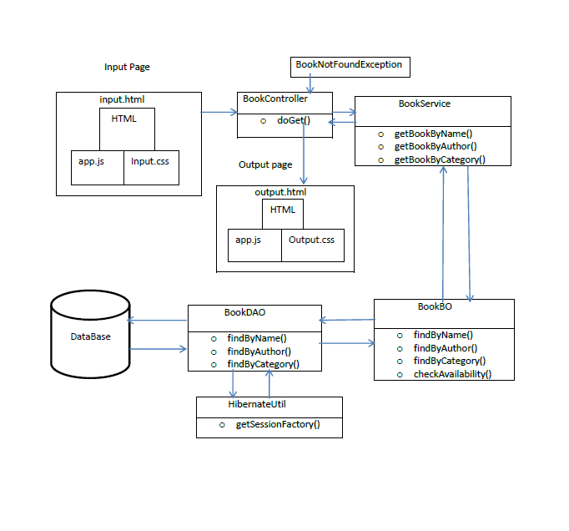

Sequence diagram

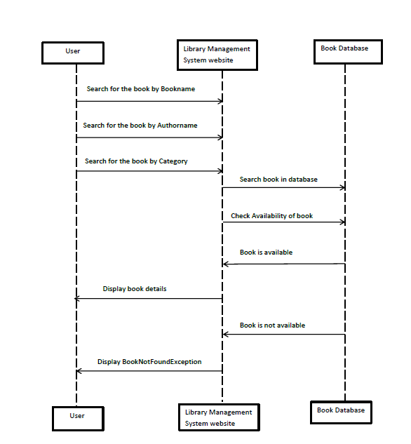

Proposed user Interface design

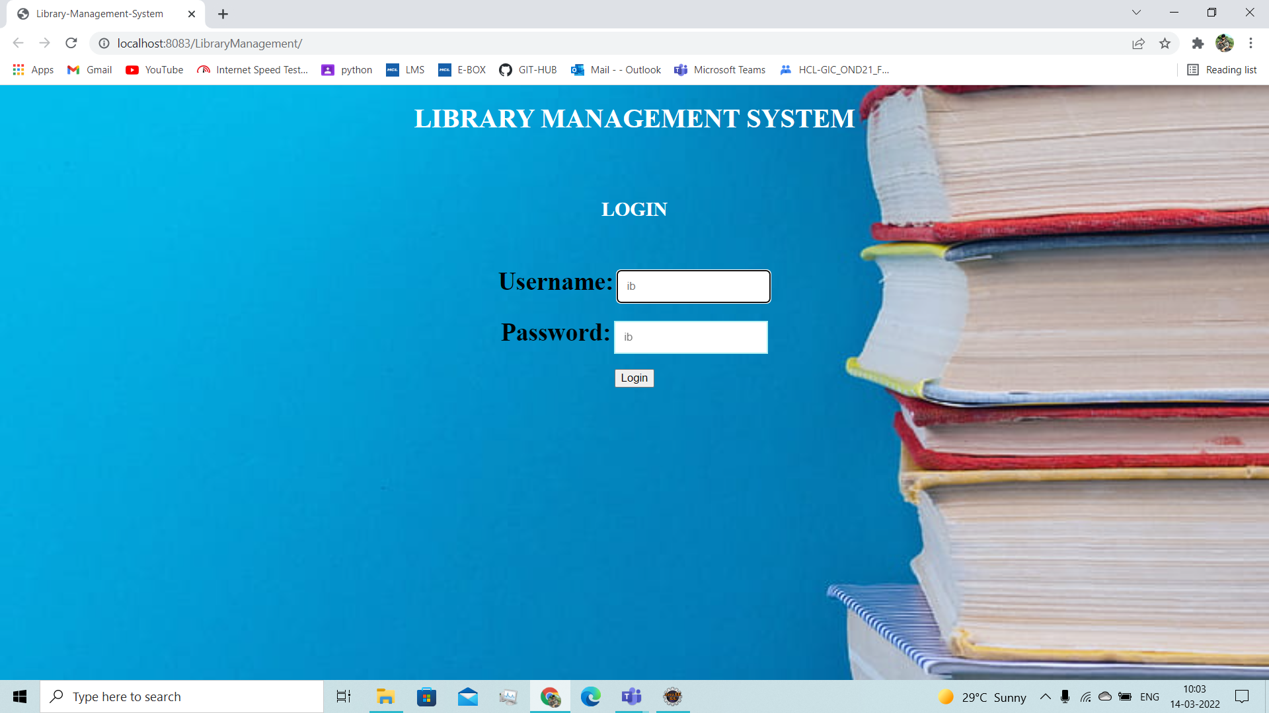

Brief Description | Login
Basic Flow | This page describes how a user log-in in to the system  - The user has to login himself into the system.  - After the successful login, user will be taken to the appropriate landing page.  - The following information is required to login.  - username  - password
Alternate Flow | - The system will validate the credentials provided. If credentials are invalid, login form will be redirected again with error message.
Validation | - Valid username  - Valid password
Pre-Conditions | User should have network access and Browser with latest updates.
Post-Conditions | Welcome page has to be displayed.

<Document the various interfaces available to the user through this story and module>

Database design changes
<Provide the logical design of the base data structures used to store the data. E.g. Like tables, and views or entities and relationships>

Refactoring related changes

<Mention details of code re-factoring requirements; objective and scope of re-factoring and Changes to be done >

Construction strategy and re-use
< Mention about automated code development (using code-generator) or manual coding. Also identify make/buy/reuse components involved, if any >

Details of Alternative Design Approach
<Details of the alternative approach to resolve the maintenance request>

Other Technical changes

Automation tasks
<if the story is about automation (of test cases or some POC etc.), mention the details here>

CI / Build relates tasks
<If the story requirements are about implementation of continuous integration or build, update the details to be done here>

Non-functional related changes
<Non-functional requirements related to response time, System load or Network load>

Additional details

Open Questions / clarifications / Assumptions
<Mention the details of any open technical questions/clarifications or assumptions made, pertaining to story >

Additional notes to technical team
<provide details if any>

References
< Provide reference details if any >

